Exercise 1: Configuring a Basic Spring Application

Scenario
A company is developing a web application for managing a library, and the Spring Framework is used to handle the backend operations. This exercise sets up a small Spring project where a service class depends on a repository class, and the wiring between them is configured through an XML file instead of being written by hand.

Objective
Create a Maven project, add the Spring Core dependency, configure beans for a service and a repository class using XML-based configuration, and run a main class that loads the Spring context and calls the service to confirm everything is wired correctly.

Project Setup
The project was created as a plain IntelliJ IDEA project and converted into a Maven project so Spring's dependency could be added and managed automatically.
- A pom.xml file was added at the project root and the spring-context dependency was declared inside it.
- The standard Maven folders src/main/java and src/main/resources were created.
- A package com.library.repository was created, containing the class BookRepository.
- A package com.library.service was created, containing the class BookService, which depends on BookRepository.
- An XML file named applicationContext.xml was added under src/main/resources, defining beans for both classes and wiring BookRepository into BookService through setter injection.
- A class named MainApp was added directly inside com.library to load the Spring context and test the configuration.
- The project's JDK was corrected to Java 17 in Project Structure, since the module was initially configured for an unsupported older JVM target.
- MainApp was run, and the console output was verified.

pom.xml
The Spring Core dependency added to the Maven configuration file:
<project xmlns="http://maven.apache.org/POM/4.0.0">
<modelVersion>4.0.0</modelVersion>

<groupId>com.library</groupId>
<artifactId>LibraryManagement</artifactId>
<version>1.0</version>

<properties>
<maven.compiler.source>17</maven.compiler.source>
<maven.compiler.target>17</maven.compiler.target>
</properties>

<dependencies>
<dependency>
<groupId>org.springframework</groupId>
<artifactId>spring-context</artifactId>
<version>5.3.30</version>
</dependency>
</dependencies>
</project>

BookRepository.java
A simple repository class that stands in for a real data source and returns a book by its ID:
package com.library.repository;

public class BookRepository {

public String getBookById(int id) {
return "Book with ID " + id + ": The Great Gatsby";
}
}

BookService.java
The service class depends on BookRepository. It exposes a setter, which is how Spring will inject the repository into it:
package com.library.service;

import com.library.repository.BookRepository;

public class BookService {

private BookRepository bookRepository;

public void setBookRepository(BookRepository bookRepository) {
this.bookRepository = bookRepository;
}

public String findBook(int id) {
return bookRepository.getBookById(id);
}
}

applicationContext.xml
This configuration file tells Spring to create both beans and inject BookRepository into BookService via the setBookRepository setter:
<beans xmlns="http://www.springframework.org/schema/beans"
xmlns:xsi="http://www.w3.org/2001/XMLSchema-instance"
xsi:schemaLocation="http://www.springframework.org/schema/beans
http://www.springframework.org/schema/beans/spring-beans.xsd">

<bean id="bookRepository" class="com.library.repository.BookRepository" />

<bean id="bookService" class="com.library.service.BookService">
<property name="bookRepository" ref="bookRepository" />
</bean>

</beans>

MainApp.java
This class loads the Spring context from the XML file, retrieves the bookService bean, and calls it to confirm the wiring works:
package com.library;

import com.library.service.BookService;
import org.springframework.context.ApplicationContext;
import org.springframework.context.support.ClassPathXmlApplicationContext;

public class MainApp {

public static void main(String[] args) {
ApplicationContext context =
new ClassPathXmlApplicationContext("applicationContext.xml");

BookService bookService = (BookService) context.getBean("bookService");

System.out.println(bookService.findBook(101));
}
}

Running the Application
MainApp was run directly from IntelliJ (right-click inside the file → Run 'MainApp.main()'). The screenshot below shows the project structure, the final version of MainApp.java, and the console output produced after running the program.

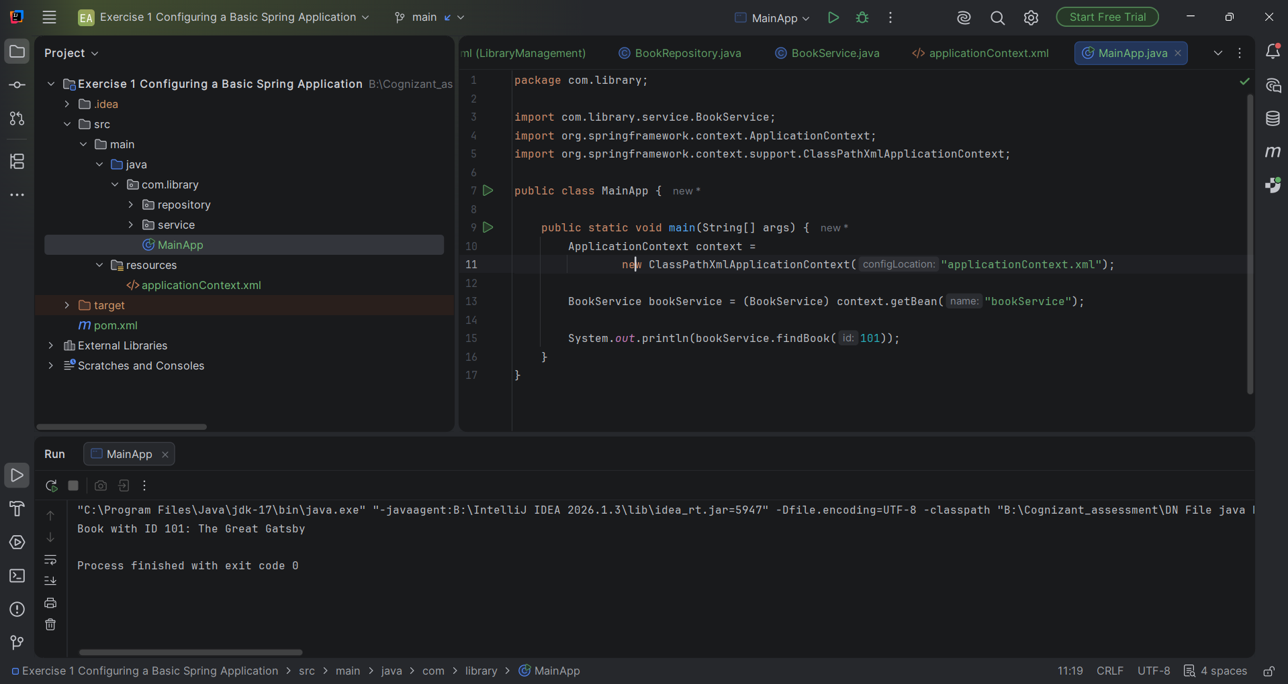
Figure 1: IntelliJ IDEA project view showing MainApp.java and the console output.

Result
Running the program produced the following console output, confirming that Spring successfully loaded the XML configuration, created both beans, and injected BookRepository into BookService:
Book with ID 101: The Great Gatsby

Process finished with exit code 0

Conclusion
This exercise demonstrated how to configure a basic Spring application using XML-based configuration. A repository and a service class were defined, their beans were declared in applicationContext.xml, and Spring took care of creating both objects and injecting the repository into the service through a setter method. The successful console output confirms that the Spring context loaded correctly and that dependency injection worked as expected, without either class needing to construct its own dependencies manually.

